**BUG NPM**

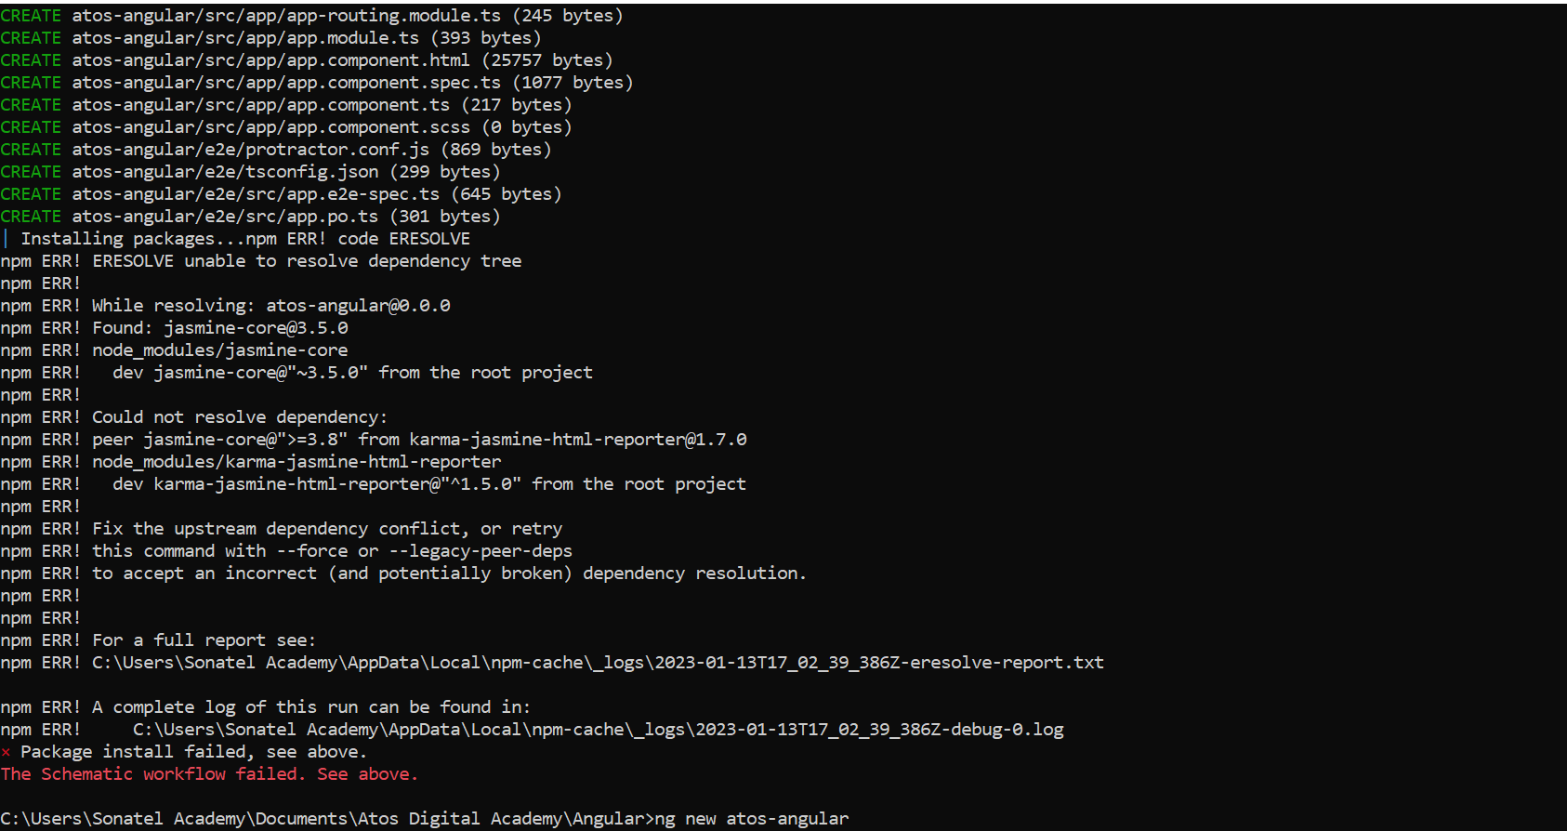

Lien de correction => <https://stackoverflow.com/questions/71582397/eresolve-unable-to-resolve-dependency-tree-while-installing-a-pacakge>

La commande idéale => npm config set legacy-peer-deps true